**WOMEN TECHSTERS FELLOWSHIP 2021**

**DATA SCIENCE AND AI TRACK**

**MINI PROJECT**

**GROUP 7**

**TOPIC:**

**CLIMATE CHANGE AND ITS EFFECT ON CROP YIELD IN DEVELOPING COUNTRIES.**

**GROUP MEMBERS:**

* **Mary Akinsande:** data mining, data cleaning, power point presentation.
* **Oluchukwu** **Okorie:**data cleaning, statistical modelling, data engineering.
* **Lilian Ugwu**: Proposal writing, Data mining and data cleaning.
* **Oreoluwa Daramola:** data cleaning and Data visualization.
* **Hamdiya Adams:** data mining and data visualization.
* **Maryam Adesokan:** data mining, data cleaning.
* **Kenechukwu Jane:** Excel and data visualization.
* **Olajumoke Bakare:** data mining.
* **Ibukunoluwa Ogunnaike:**Datapre-processing.

**TABLE OF CONTENTS**

* + 1. Introduction
    2. Hypothesis
    3. Research Questions
    4. Goals & Objectives of the Project
    5. Methodology
    6. Data Science project life cycle
    7. Procedure
    8. Data visualization
    9. Discussion
    10. Conclusion

**Introduction**

Global warming has become one of the most common environmental issues discussed. This is due to the impacts global warming has on crop yields, weather patterns, sea levels and ecological systems.  Since 1850, when the record of global temperature began to be kept, temperature is always on the increase and temperature is expected to increase by 1.8 to 8.5 0C by the end of this century(1). Global warming is caused by the emission of greenhouse gases like carbon dioxide, methane, chlorofluorocarbons, and nitrous oxide (3).

These gases have an insulating effect on the climate which causes the atmosphere to trap heat and warm the earth. The actives of this gases on the climate affect the soil which in turns affect crop yield (1).

With the world population excepting to hit a double by 2050, global food production would have to double to meet the need of rising population (4).  The threat to food security from climate change is a critical issue for a number of businesses like food and beverages, retails, agriculture, insurance, biofuels, transportation and so on.  Developing countries may be more at risk of food scarcity. Governments across the globe need to be well equipped to deal with economic shocks that may arise as a result of shortage in crop yield (4).

**Hypothesis:** Does climate change have an effect on crop production in developing countries?

**Research Questions:**

* Is there a correlation between an increase in temperature and crop yield?
* Does the amount of rain fall affect crop yield in developing regions?

**Goal of the Study**

The goal of this study is to perform an exploratory analysis on how the variables of climate change, that is, temperature and rainfall pattern affects crop yields.

Knowing that developing regions are more vulnerable to the risks that climate change pose, we streamlined our scope to include four countries represented in the Women Techsters Fellowship, which are Ghana, Nigeria, Kenya, and South Africa and the varieties of crop commonly produced in those area which are Rice, Maize, Millet, Cotton and Sugarcane.

**Objectives**:

* 1. To determine the extent to which variations in temperature, affect crop yield in these different countries.
  2. To determine the extent in which variations in rainfall patterns, affect crop yield in different these countries.

**Methodology:**

This project uses the standard structure for data science projects, which is iterative in nature. It involves the following stages:

* **Data Collection:**

Crop yield data is taken from [https://ourworldindata.org](https://ourworldindata.org/) and weather indices data is taken from [https://datahub.com](https://datahub.com/) .

* **Data Understanding:**

A lot of research was carried out by members of the team concerning the subject matter. Detection of data quality problems, forming hypothesis from the data and also the discovery of primary insights and patterns in the data.

* **Data Cleaning and Pre-processing:**

 Data cleaning involved using excel to filter and reconstruct the data. Python was also used to drop unnecessary columns that were not needed for the study. Data Pre-processing involved exploring the data and making analysis on it using Python in Jupyter notebook

* **Date Visualization:**

This involved using Python libraries like Pandas, Numpy, Matplotlib and Seaborn to clearly describe the data in pictures, graphs and images.

**Definition of Some Important Terms used in this Project**

1. Annual Crop Yield Gap: Crop yield gap is the difference between yield potential and average farmers yield over a specified area or period of time i.e. the higher the yield gap the lower the production.(1)
2. Climate: Climate is a given weather of a place, over a long period of time.(5)
3. Climate change: Climate change is the systemic change in the long time weather condition of a given place. (5)

**Procedure:**

A step by step procedure used to carry this project out include;

* 1. Importing the necessary libraries- Numpy (for numerical calculations), Pandas (for reading and importing the dataset), Matplotlib and Seaborn (for visualization), Sklearn (for preprocessing and normalization of data).
  2. Importing the datasets- The data sets used in this project as imported as CSV files into the notebook using pandas
  3. Cleaning the dataset- The dataset was normalized, the names of some columns were renamed for better workflow and constants were created.
  4. Visualizing the Data: Matplotlib was used to plot graphs of different variables and to show how each of them affect the rate of each other. The annual crop yield gap for each of the crops were shown in graphs. The relationship between annual mean temperature/mean rainfall and crop yield was also visualized using scatter plots.
  5. The correlation between the annual mean temperature and mean rainfall and crop yield was calculated to using the Spearman rank correlation coefficient.

**Result**

**Annual crop yield of crops:**

**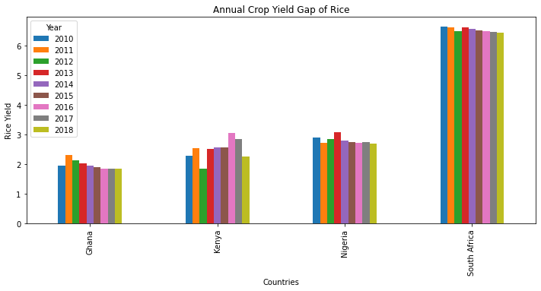**

**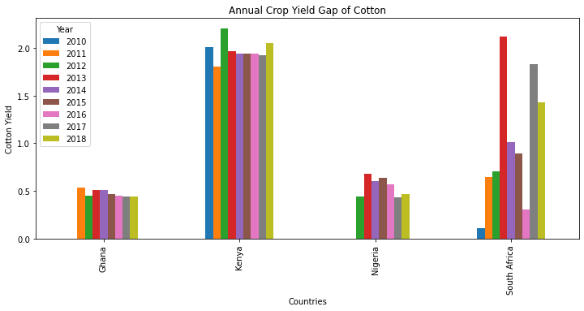**

**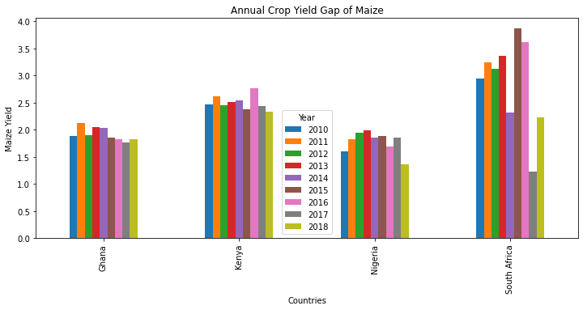**

**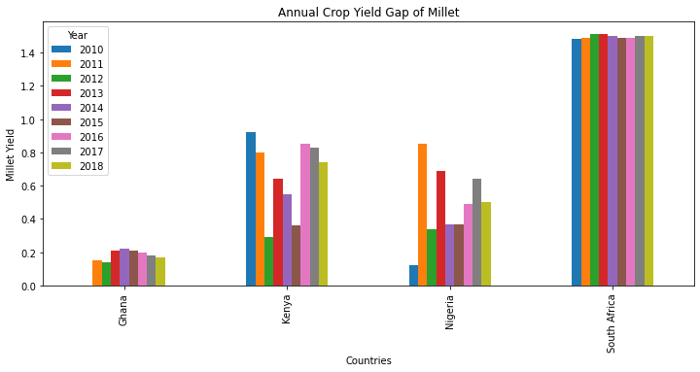**

**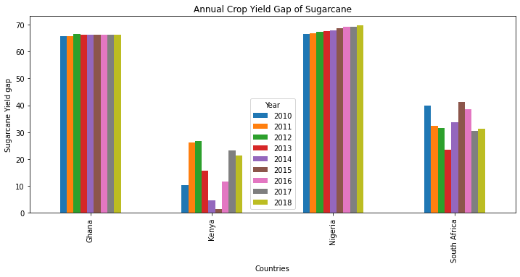**

**Average Temperature of the Countries**

**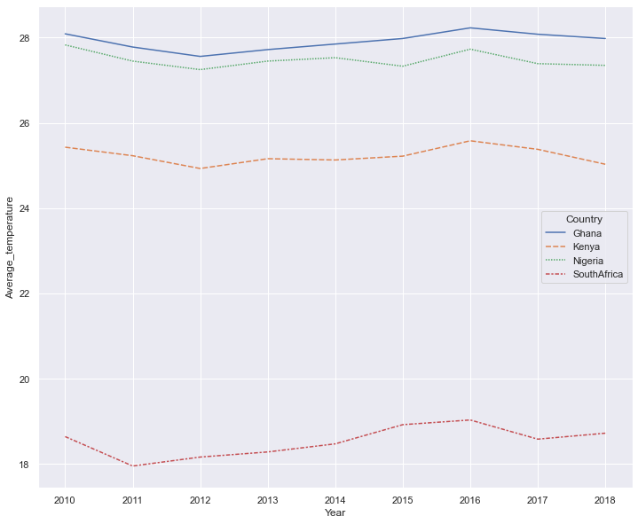**

**Annual Mean Temperature and Crop Yield**

VISUALISING THE RELATIONSHIP BETWEEN ANNUAL MEAN TEMPERATURE AND CROP YIELD.

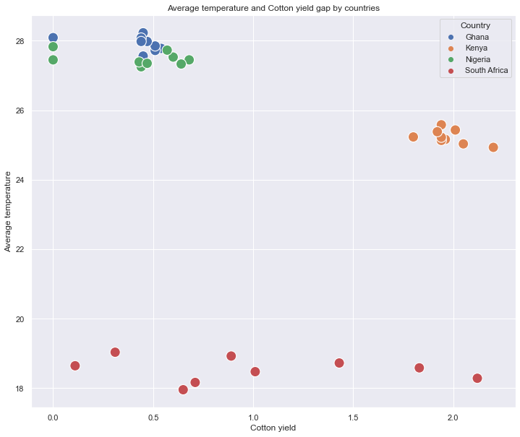

**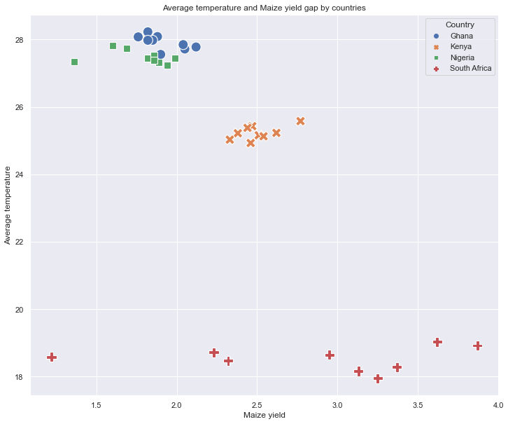**

**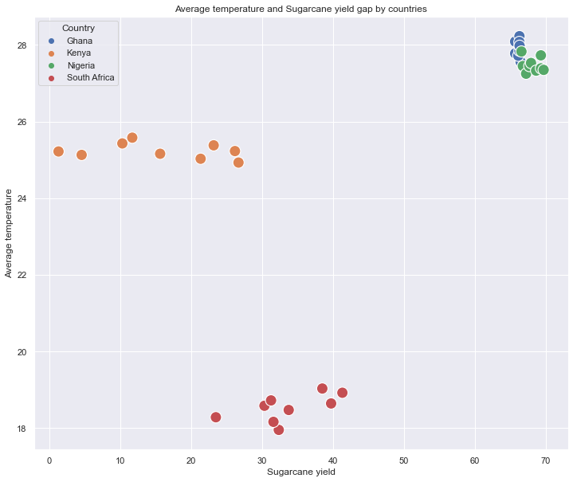**

**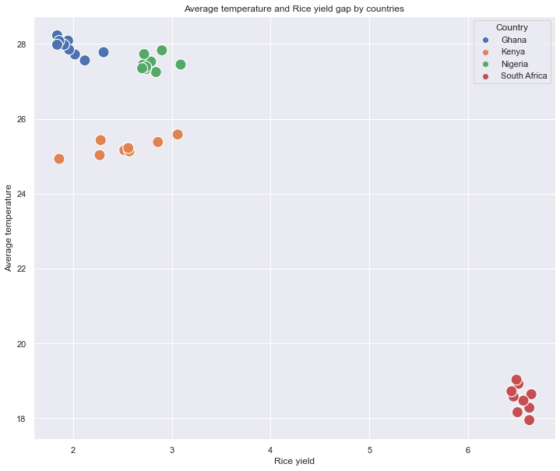**

**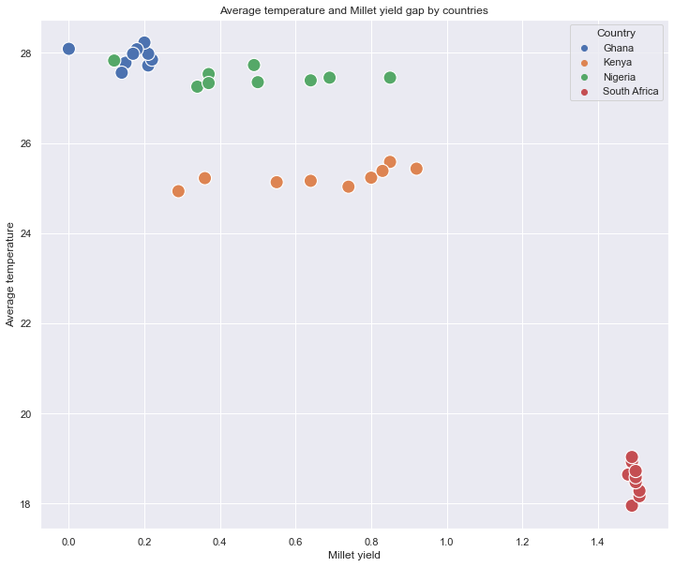**

# ANNUAL RAINFALL AND CROP YIELD

VISUALISING THE RELATIONSHIP BETWEEN RAINFALL AND CROP YIELD

**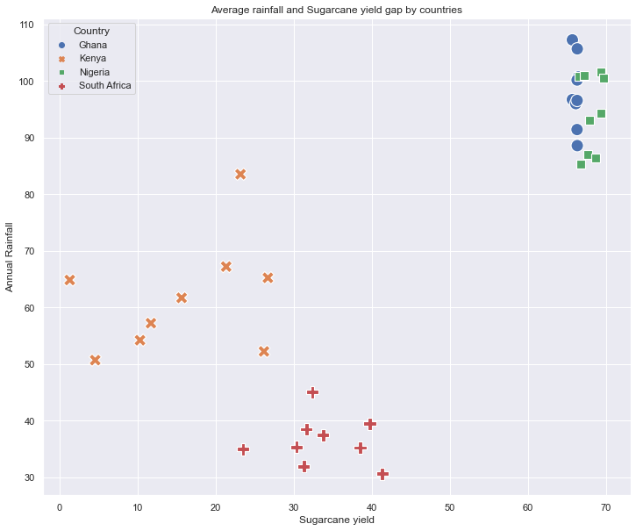**

**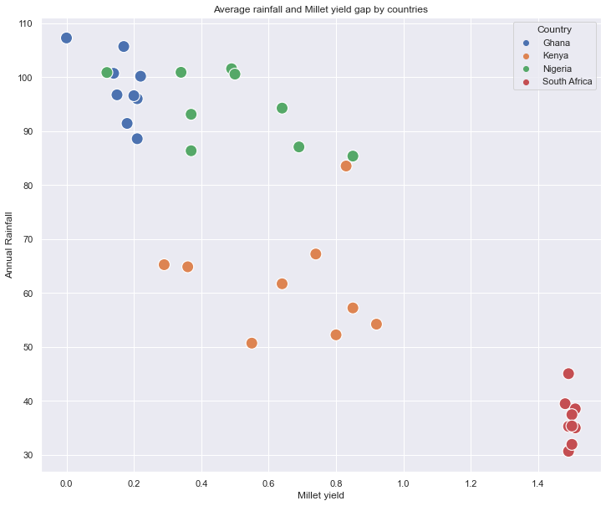**

**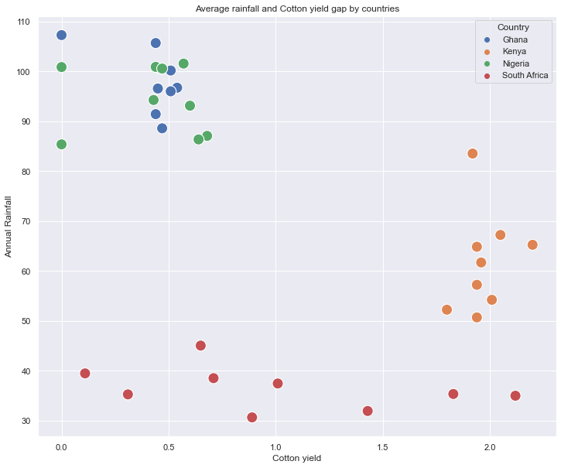**

**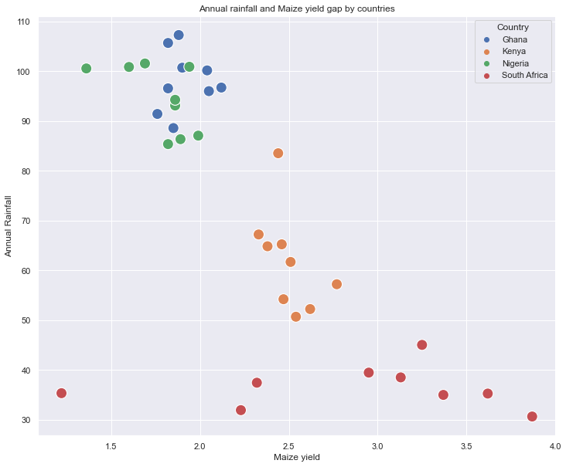**

**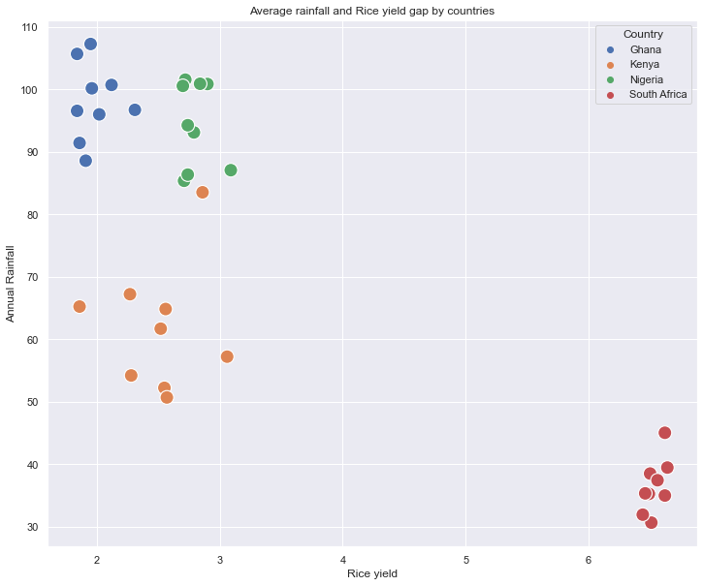**

**Discussion:**

With visual analysis of the crop production over the past 8 years and climate change (rainfall and temperature) over the period of 8 years, it has been observed that climate indeed

influences yield gap and are statistically significant to the crop production. Previous

studies have showed there is correlation, to estimate the conditional dependence of yield on weather indices. This study, therefore, uses Spearman's rank correlation coefficient.

This correlation assessed monotonic relationships (whether linear or not). If there are no

repeated data values, a perfect Spearman correlation of +1 or −1 occurs when each of the variables is a perfect monotone function of the other. In our project we had a Correlation

coefficient of -0.9271463585621841 and -0.9240669240669243 for the relationship

between annual temperature and annual rainfall with crop yield. The negative sign shows that there is a negative/inverse relationship between the variables in question, but since it is closer to -1, it is highly correlated. The P-value is also found to be less than 0.05 which makes it statistically significant.

Also, it is shown that there is an optimal temperature at which certain crops grow well, it is observed in this, that at 27oC temperature, countries have a lower yield gap and as such produces more crop production for consumption. However, global warming increases daily and with time it is possible this optimal conditions for crop growth may not be achieved.

However, multiple studies have shown relationship between crop yield and weather indices and is characterized by the existence of critical thresholds.

**Conclusion:**

Based on our findings, to a very large extent climate change affect crop production and the yield gap annually. However some crops like sugarcane are still favored by the climate change which is gown more in countries like Kenya and Nigeria.​

**RECOMMENDATIONS:**

The following are the recommendations to aid better crop production:​

1. Use of alternative sources of fuel that are environmentally friendly. E.G. Biogas and geothermal energy.​
2. Reduced carbon concentration in the atmosphere by gradually banning the use of carbon emitting automobiles ​
3. Reduce depends on rain fed agriculture and practice irrigation farming.​
4. Due to the time frame of the project we were able to cover 8 years, for a more in depth view on climate change we recommend more years and countries to be covered.​

**Keywords**: climate change, temperature, yield gap, average rain fall,

**References:**

1. Online:[https://towardsdatascience.com/climate-change-and-food-scarcity-in-developing-regions-an-analysis-in-python-d8ca5ec5f496nces](https://towardsdatascience.com/climate-change-and-food-scarcity-in-developing-regions-an-analysis-in-python-d8ca5ec5f496nces" \t "_blank).
2. Asseng, S., Ewert, F., Rosenzweig, C., Jones, J. W., Hatfield, J. L., Ruane, A. C., et al. (2013). Uncertainty in simulating wheat yields under climate change. *Nat. Clim. Change* 3, 827–832. doi: 10.1038/nclimate1916.
3. Osborne, T. M., and Wheeler, T. R. (2013). Evidence for a climate signal in trends of global crop yield variability over the past 50 years. *Environ. Res. Lett*. 8:024001. doi: 10.1088/1748-9326/8/2/024001.
4. Konduri VS, Vandal TJ, Ganguly S and Ganguly AR (2020) Data Science for Weather Impacts on Crop Yield. *Front. Sustain. Food Syst.* 4:52. doi: 10.3389/fsufs.2020.00052.
5. Online: https://www.climateurope.eu/what-is-climate-and-climate-change/